RAJALAKSHMI ENGINEERING COLLEGE

RAJALAKSHMI NAGAR, THANDALAM - 602 105

# RAJALAKSHMI

## ENGINEERING COLLEGE

An AUTONOMOUS Institution

Affiliated to ANNA UNIVERSITY, Chennai

(REGULATION 2023)

|  |  |
| --- | --- |
| CS23432  Software Construction | |
| DEPARTMENT OF ARTIFICIAL INTELLIGENCE AND MACHINE  LABORATORY RECORD NOTEBOOK | |
| AKSHAYA NAIR SS Name:  2nd/AIML/FA  Year/ Branch / Section : .  .  2116-231501011 Register No.:  .  4th Semester  Semester :  2024-2025  Academic Year: | |



### RAJALAKSHMI ENGINEERING COLLEGE (AUTONOMOUS)

RAJALAKSHMI NAGAR, THANDALAM- 602 105



#### BONAFIDE CERTIFICATE

AKSHAYA NAIR SS 2116-231501011 NAME REGISTER NO.



ACADEMIC YEAR 2024-25 SEMESTER-IV BRANCH: AIML-B.Tech

This Certification is the Bonafide record ofwork done by the above student

in the CS23432- Software Construction Laboratory during

the year 2024 2025.

Signature ofFaculty -in Charge

Submitted for the Practical Examination held on

Internal Examiner External Examiner

### INDEX

AKSHAYA NAIR SS AIML Sec:Roll no: [1]Name: Branch:

|  |  |  |  |  |
| --- | --- | --- | --- | --- |
| s.  No. | Date | TITLE | Page No. | Teacher's  Signature  Remarks |
| 1. | 8/2/25 | Azure DevOps Environment Setup |  |  |
| 2. | 15/2/25 | Azure DevOps Project Setup and User Story Management |  |  |
| 3. | 22/2/25 | Setting Up Epics, Features, and User Stories for Project Planning |  |  |
| 4. | 1/3/25 | Sprint Planning |  |  |
| 5. | 8/3/25 | Poker Estimation |  |  |
| 6. | 22/3/25 | Designing Class and Sequence Diagrams for Project Architecture |  |  |
| 7. | 29/3/25 | Designing Architectural and ER Diagrams for Project Structure |  |  |
| 8. | 5/4/25 | Testing — Test Plans and Test Cases |  |  |
| 9. | 12/4/25 | Load Testing and Performance Testing |  |  |
| 10. | 19/4/25 | Github: Project Structure & Naming Conventions |  |  |

|  |  |
| --- | --- |
| EXP NO: 1 DATE: | AZURE DEVOPS ENVIRONMENT SETUP |

Aim:

To set up and access the Azure DevOps environment by creating an organization through the Azure portal.

INSTALLATION

I. Open your web browser and go to the Azure website: https://azure.microsoft.com/enus/get- started/azure-portal.

Sign in using your Microsoft account credentials.

If you don't have a Microsoft account, you can create one here: https://signup.live.com/?lic=l

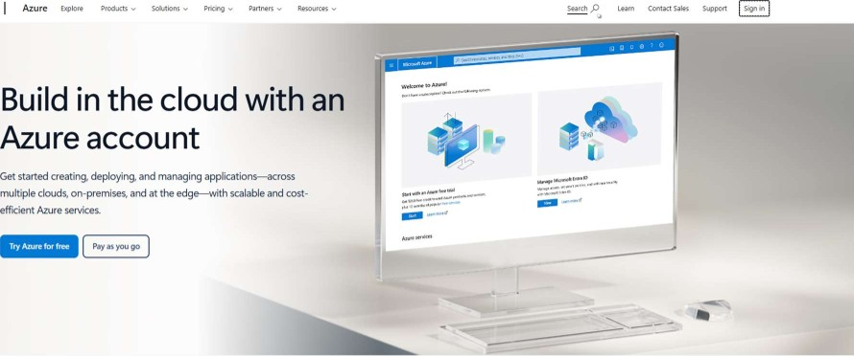

Microsoft

Choose the Azure account that's right for you

as you Azure fee to There upfront

231501011

1. Azure home page

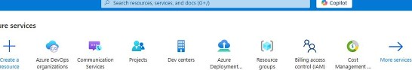

Azu

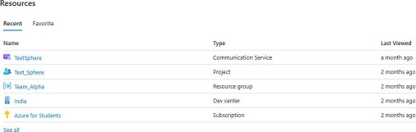



useful links A.ure mobile app



1. Open DevOps environment in the Azure platform by typing Azure DevOps Organizations in the search bar.

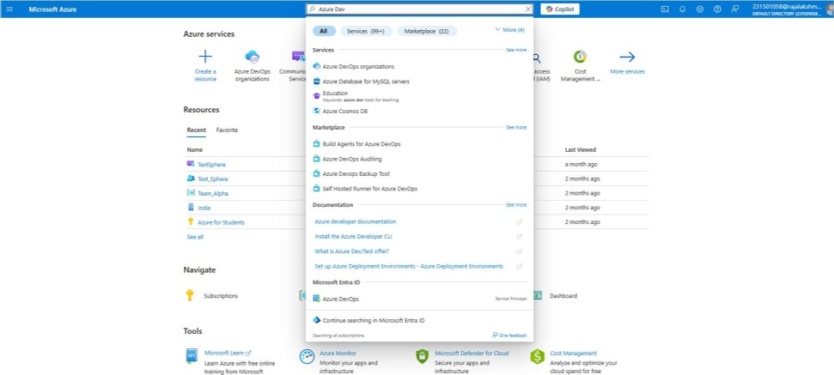

1. IIC on the My Azure DevOps Organization link and create an organization and you shoulfi23432 taken to the Azure DevOps Organization Home page.

Azure DevOps

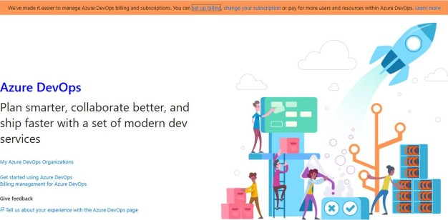

Result:

Successfully accessed the Azure DevOps environment and created a new organization through the Azure portal.

231501011

|  |  |
| --- | --- |
| EXP NO: 2 | AZURE DEVOPS PROJECT SETUP AND USER STORY  MANAGEMENT |

Aim:

To set up an Azure DevOps project for efficient collaboration and agile work management.

I. Create An Azure Account

|  |
| --- |
| Azure DevOps  231501058@rajalakshmi.edu.in  Get started with Azure DevOps  Choosing Continue means that you agree to our *case and CQdg-gf-CQ2dusg.  I would like information, tips. and offers about Azure  DevOps and Other Microsoft products and Staternent |

1. Create the First Project in Your Organization
   1. After the organization is set up, you'll need to create your first project. This is where you'll begin to manage code, pipelines, work items, and more.
   2. On the organization's Home page, click on the New Project button.
   3. Enter the project name, description, and visibility options:

Name: Choose a name for the project (e.g., LMS).

Description: Optionally, add a description to provide more context about the project. Visibility: Choose whether you want the project to be Private (accessible only to those invited) or Public (accessible to anyone).

* 1. Once you've filled out the details, click Create to set up your first project.

231501011

|  |  |  |  |  |
| --- | --- | --- | --- | --- |
| Create new project x  Project name   |  | | --- | | Text.Sphere |   Description   |  | | --- | | SMS/Text Messaging Service : Build a web-based or mobile application that can send and receive SMS or text messages. potentially with additional features like scheduling, group messaging. or integration with other communication channels. |   Visibility   |  | | --- | | Private  Only people you g access to will be able to view this project. |   Public  Anyone on the internet can view the pr*ct. Certain features like TFVC are not supported  Public projects are disabled for your organization. You can tum on public visibility with QigangatiQ!L2Qlicies.  A Advanced   |  | | --- | | I Agile |   Version control O Work item process O |

1. Once logged in, ensure you are in the correct organization. If you're part of multiple organizations, you can switch between them from the top left corner (next to your user profile). Click on the Organization name, and you should be taken to the Azure DevOps Organization Home page.

 Azure DevOps Organizations 

v dev.azure.com/TextSphereMain (Owner)

Studio

New project

Harish M Edit prome

231 mi.eduin Organizations Pending Deletion - Expand

Microsoft account

India

 2315010-580raja1akshmLeduin

Visual Studio Dev Essentials

Get  "—d to build your app on any platfomn_ usc you benefits

1. Project dashboard

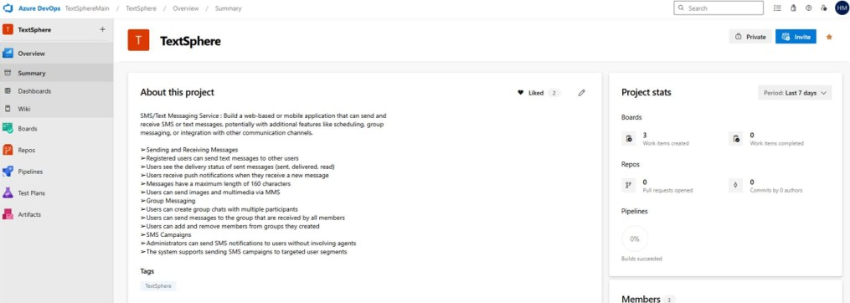

000

1. To manage user stories:
   1. From the left-hand navigation menu, click on Boards. This will take you to the main Boards page, where you can manage work items, backlogs, and sprints.
   2. On the work items page, you'll see the option to Add a work item at the top. Alternatively, you can find a + button or Add New Work Item depending on the view you're in. From the Add a work item dropdown, select User Story. This will open a form to enter details for the new User Story.

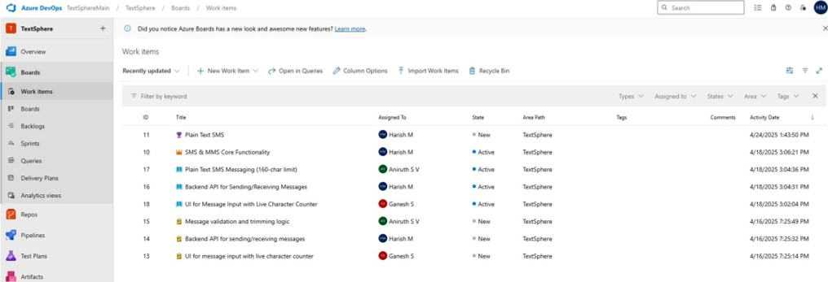

Result:

Successfully created an Azure DevOps project with user story management and agile workflow setup.

|  |  |
| --- | --- |
| EXP NO: 3 | SETTING UP EPICS, FEATURES, AND USER STORIES FOR PROJECT PLANNING |

Aim:

To learn about how to create epics, user story, features, backlogs for your assigned project.

Create Epic, Features, User Stories, Task

= TextSphere Team v Cz

Backlog Anatytics

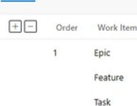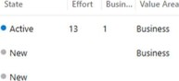TypeTags

v W SMS & MMS core Functionality

Plain rat SMS ul for with live character count«

1.Fill in Epics

10 SMS & MMS core Functionality

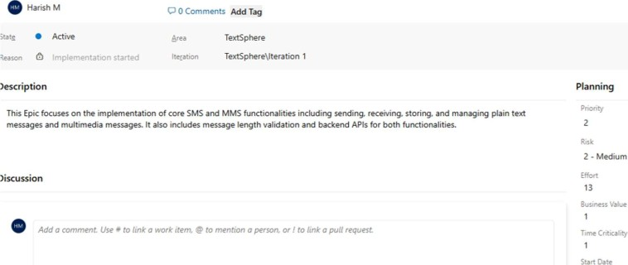

4/16/2025 7:22 PM



12m AM



2.Fill in Features

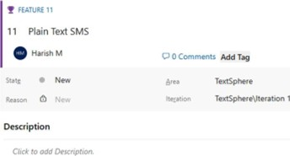Add O 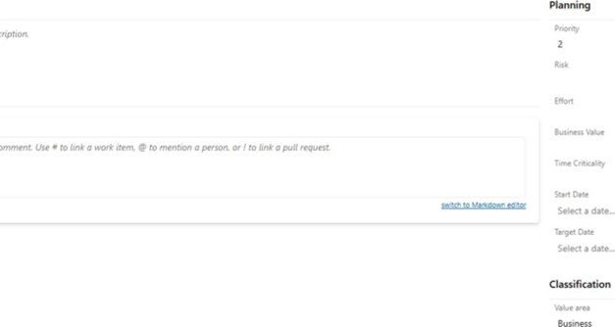

3.FiII in User Story Details

n USER 17

17 plain Text SMS Messaging (160-char limit)

Aniruth S V C) O Comments Tag

|  |  |  |
| --- | --- | --- |
| • Active | TextSphere |  |
| Reason Implementation started | Textsphere\lteration I |  |
| Description |  | Planning |

As a user. I want to send simple within 160 characters so the app feels like a real SMS interface Story points

Acceptance Criteria 

3 LOW

Acceptance Criteria:

* Only messages with s 160 characters are allowed.

Classification

* Frontend prevents submission Of long messages.
* Backend enforces the limit with validation.

Discussion

Result:

Thus, the creation of epics, features, user story and task has been created successfully.

|  |  |
| --- | --- |
| EXP NO: 4 | SPRINT PLANNING |

Aim:

To assign user story to specific sprint for the SMS/MMS Sending Project.

#### Sprint Planning Sprint 1

A TextSphere Team v o 

Taskboud Backlog Capacity Analytics



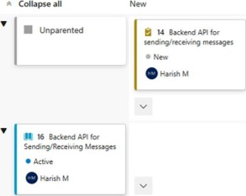

Iteration

I

v

An

v

|  |
| --- |
| Input |

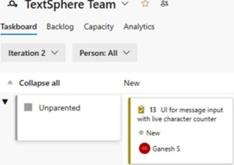

v

Sprint

2

|  |
| --- |
| SMS |

Sprint 3

A TextSphere Team v

Taskb0Md Backlog Capacity Analytics



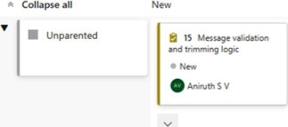

Result:

The Sprints are created for SMS/MMS Sending Project.

|  |  |
| --- | --- |
| EXP NO: 5 | POKER ESTIMATION |

Aim:

Create Poker Estimation for the user stories SMS/MMS Sending Project.

Poker Estimation

USER STORY 16

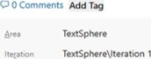16 Backend API for Sending/Receiving Messages o

 Started

Description Planning

As a registered user,

I Want to send and receive text and APIS so that I Can communicate

Acceptance Criteria

I • High rnessageS. 

to Azure Blob Storage database.

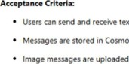

text

and

Cosmos

DB.

 Appropriate MIME type validation is enforced.

Result:

The Estimation/Story Points is created for the project using Poker Estimation.

|  |  |
| --- | --- |
| EXP NO: 6 | DESIGNING CLASS AND SEQUENCE DIAGRAMS FOR  PROJECT ARCHITECTURE |

Aim:

To Design a Class Diagram and Sequence Diagram for the given Project.

6A. Class Diagram

TextSphereMain / TextSphere Overview Wiki Class Diagram-Text Sphere

 Class Diagram-Text Sphere

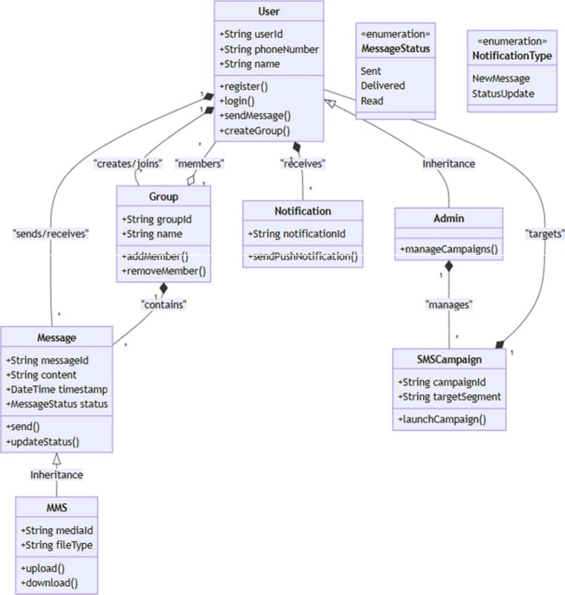

o

Harisr

V

Just

now

6B. Sequence Diagram

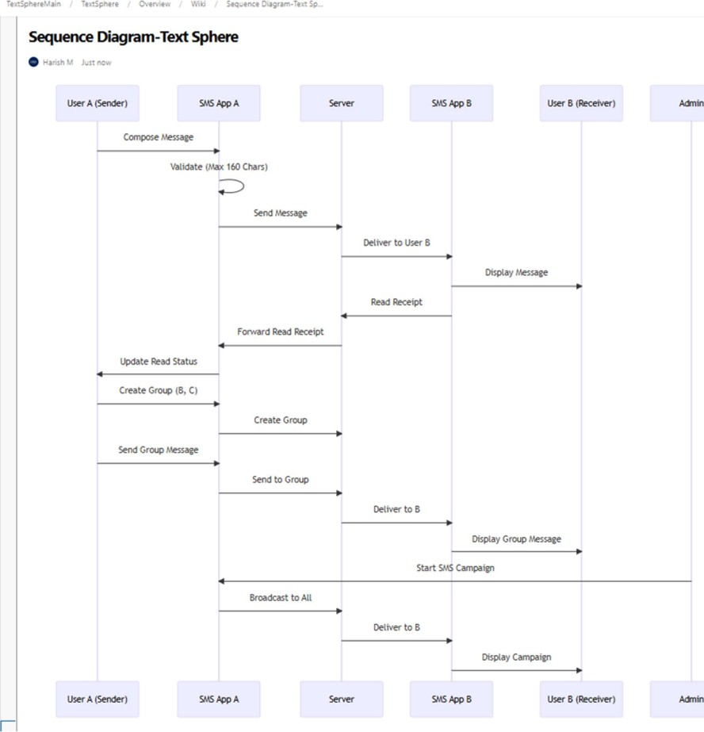

Result:

The Class Diagram and Sequence Diagram is designed Successfully for the SMS/MMS Sending Project

|  |  |
| --- | --- |
| EXP NO: 7 | DESIGNING ARCHITECTURAL AND ER DIAGRAMS  FOR PROJECT STRUCTURE |

Aim:

To Design an Architectural Diagram and ER Diagram for the given Project.

7A. Architectural Diagram

TextSphereMain / Texts-here f Cr.•erview / Wiki Architecture Diagram - Text

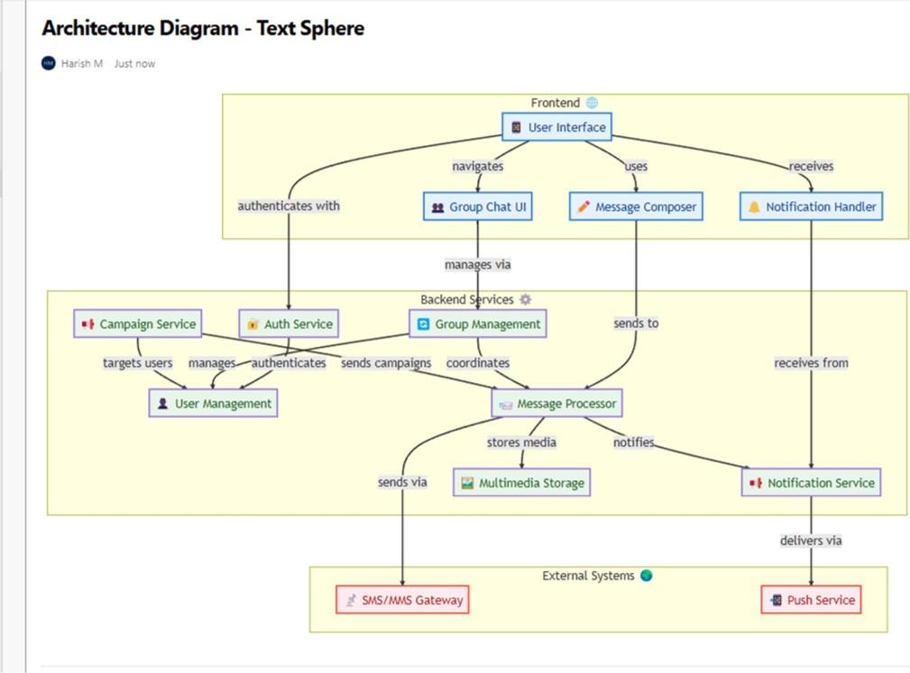

7B.ER Diagram

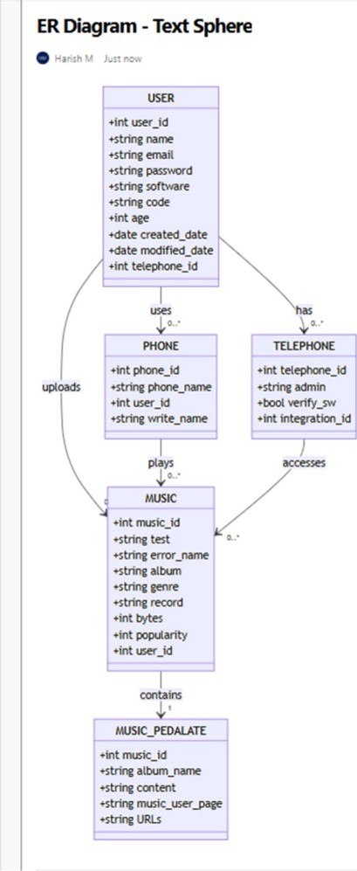

Texts-phereyain

/

TextSphere

i

Overview

I

Wiki

i

EROiagr•rn

•

Text

Sphere

Result:

The Architecture Diagram and ER Diagram is designed Successfully for the Music Playlist Batch

Creator

|  |  |
| --- | --- |
| EXP NO: 8 | TESTING - TEST PLANS AND TEST CASES |

Aim:

Test Plans and Test Case and write two test cases for at least five user stories showcasing the happy path and error scenarios in azure DevOps platform.

SMS/Text Messaging Service - Test Plans

Here's the test plan, incorporating your user stories and providing a structure for testing in Azure DevOps:

#### USER STORIES

* As a user, I want to send and receive text messages to other users (ID: SMSOI).
* Users see the delivery status of sent messages (sent, delivered, read) (ID: SMS02).
* Users receive push notifications when they receive a new message (ID: SMS03).
* Messages have a maximum length of 160 characters (ID: SMS04).
* Users can send images and multimedia via MMS (ID: SMS05).
* Users can create group chats with multiple participants (ID: SMS06).
* Users can send messages to the group that are received by all members (ID: SMS07).
* Users can add and remove members from groups they created (ID: SMS08).
* Administrators can send SMS notifications to users without involving agents (ID: SMS()9).  The system supports sending SMS campaigns to targeted user segments (ID: SMS 10).

Test Suites

Here's how the test suites could be organized in Azure DevOps, based on the user stories:

* Test Suite: TSOI - Sending and Receiving Messages (ID: 91)
* Test Suite: TS02 - Message Delivery Status (ID: 92)
* Test Suite: TS03 - Push Notifications (ID: 93)
* Test Suite: TS04 - Message Length Validation (ID: 94)
* Test Suite.• TS05 - Multimedia Messaging (MMS) (ID: 95)
* Test Suite: TS06 - Group Messaging - Creation (ID: 96)
* Test Suite.• TS07 - Group Messaging - Sending Messages (ID: 97)
* Test Suite: TS08 - Group Messaging - Membership Management (ID: 98)
* Test Suite.• TS09 - SMS Campaigns - Sending (ID: 99)
* Test Suite.• TSIO - SMS Campaigns - Targeting (ID: 100)

Test Cases

Test Suite: TSOI - Sending and Receiving Messages (ID: 91)

TC01 - Successful Message Send and Receive (ID: 101)  Action:

* Log in as User A.
* Compose a new message to User B.  Enter valid text within the character limit.
* Click "Send."
* Log in as User B.
* Open the message from User A.

 Expected Results:

* User A: Message is sent successfully.
* User B: Message is received and displayed correctly.
* Type: Happy Path

2. TC02 - Send Message to Invalid User (ID: 102) o Action:

* Log in as User A.
* Compose a new message to a non-existent user ID.
* Enter valid text.  Click "Send."  Expected Results:
* Error message is displayed: "Recipient user not found. "  Message is not sent.
* Type: Error Path

Test Suite: TS02 - Message Delivery Status (ID: 92)

TC03 - Verify Message Delivery Status Updates (ID: 103) o Action:

* Log in as User C.
* Send a message to User D.
* Observe the message status on User C ts interface.
* Log in as User D and open the message.
* Observe the message status on User C t s interface again.

 Expected Results:

* User C: Message status changes from "Sent" to "Delivered" when User D receives it, and to "Read" when User D opens it.  Type: Happy Path

2. TC04 - Delivery Status When Recipient is Offline (ID: 104) o Action:

* Log in as User E.
* Send a message to User F, who is currently offline.
* Observe the message status on User E's interface.  Log in as User F and check for the message  Expected Results:
* User E: Message status remains "Sent" until User F comes online.  User F: User F receives the message.
* Type: Error Path

Test Suite: TS03 - Push Notifications (ID: 93)

TC05 - Receive Push Notification for New Message (ID: 105)  Action:

* Log in as User G on a mobile device with push notifications enabled.
* Log in as User H on a separate device.
* User H sends a message to User G.
* Observe User G's mobile device (with the app in the background or closed).  Expected Results:
* User G's device displays a push notification for the new message.  Type: Happy Path

2. TC06 - Push Notification Failure Due to Disabled Settings (ID: 106) o Action:

* Log in as User I on a mobile device with push notifications disabled for the messaging app.
* Log in as User J on a separate device.
* User J sends a message to User I.  Observe User I's mobile device.  Expected Results:
* User I's device does not display a push notification.  User I can still see the message when opening the app.  Type: Error Path

Test Suite: TS04 - Message Length Validation (ID: 94)

TC07 - Send Message Within Character Limit (ID: 107) o Action:

* Log in as User K.
* Compose a message with exactly 160 characters.  Click "Send. "  Expected Results:
* Message is sent successfully.
* Type: Happy Path

2. TC08 - Send Message Exceeding Character Limit (ID: 108) o Action:

* Log in as User L.
* Compose a message with 161 characters.  Click "Send. "  Expected Results:
* Error message is displayed: "Message exceeds the maximum character limit

(160)."

* Message is not sent.
* Type: Error Path

Test Suite: TS05 - Multimedia Messaging (MMS) (ID: 95)

1. TC09 - Send message with an image. (ID: 109) o Action:
   * Log in as User M.
   * Compose a new message to User N.
   * Attach a valid image file.  Click "Send."  Expected Results:
   * The image is sent and received successfully.
   * The image is displayed correctly on User N's device.
   * Type: Happy Path
2. TCIO - Send message with an unsupported file type. (ID: 110) o Action:
   * Log in as User O.
   * Compose a new message to User P
   * Attach a file of an unsupported type (e.g., .exe).  Click "Send."  Expected Results:
   * Error message is displayed: "Unsupported file type."  The file is not sent.
   * Type: Error Path

Test Cases

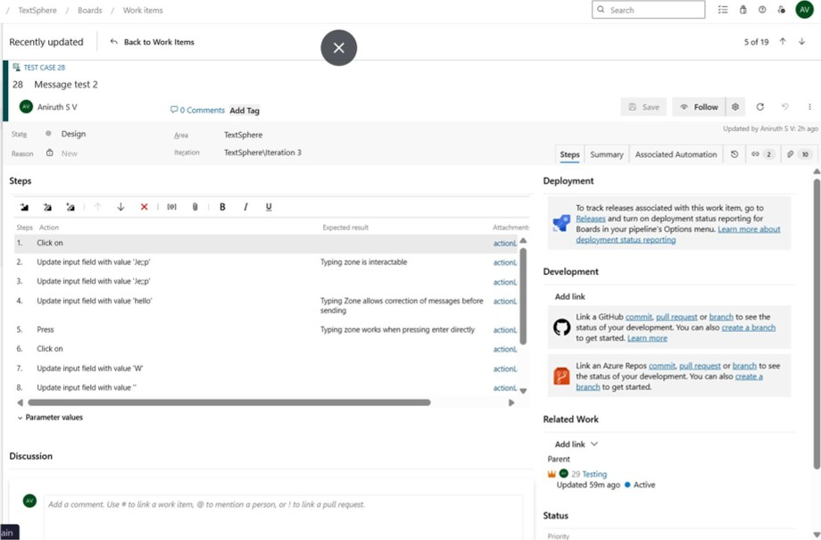



Work itetns

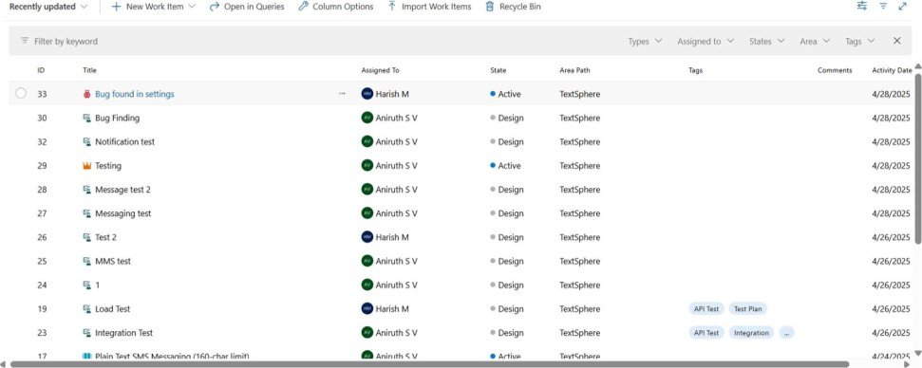

+

1. Installation of test

o

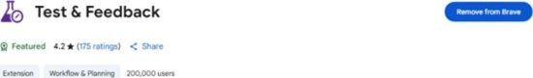

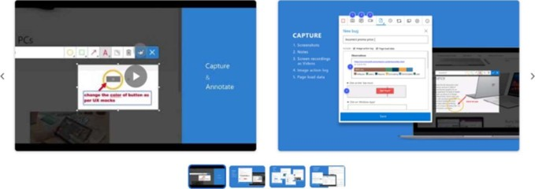

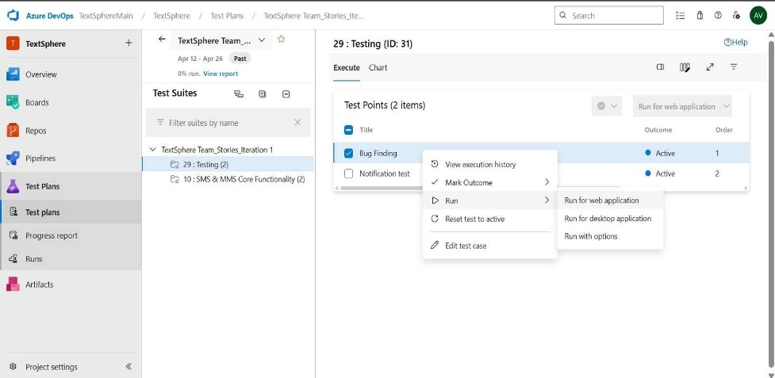

2.

Running

the

test

cases

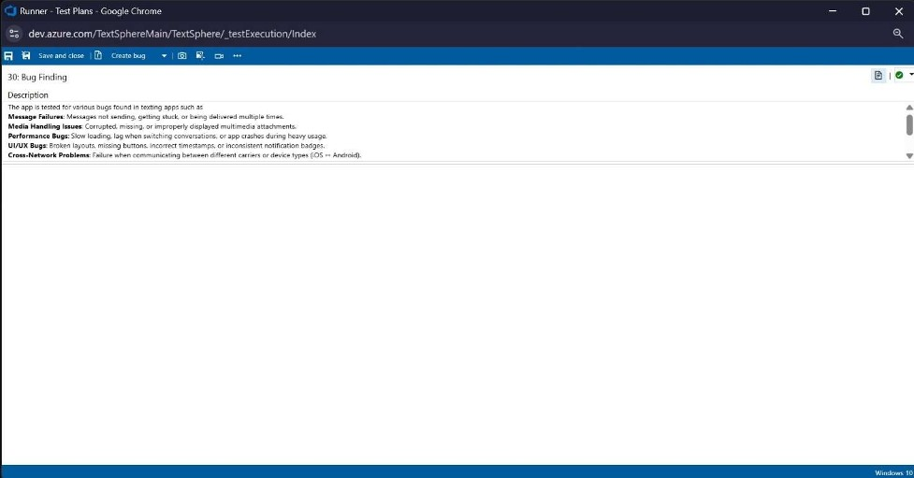

3. Recording the test case

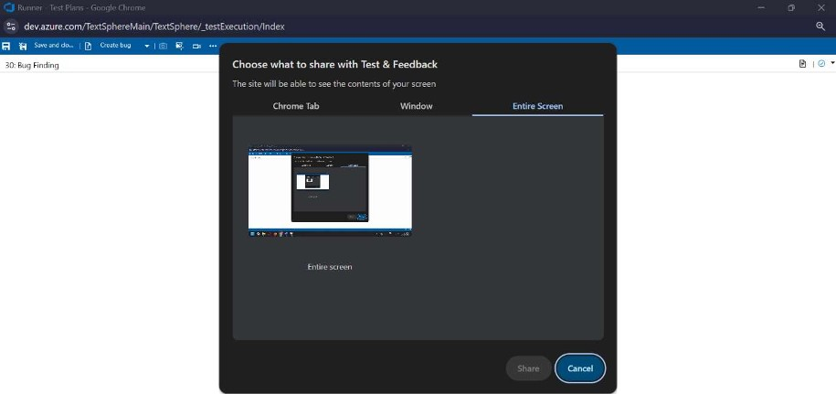



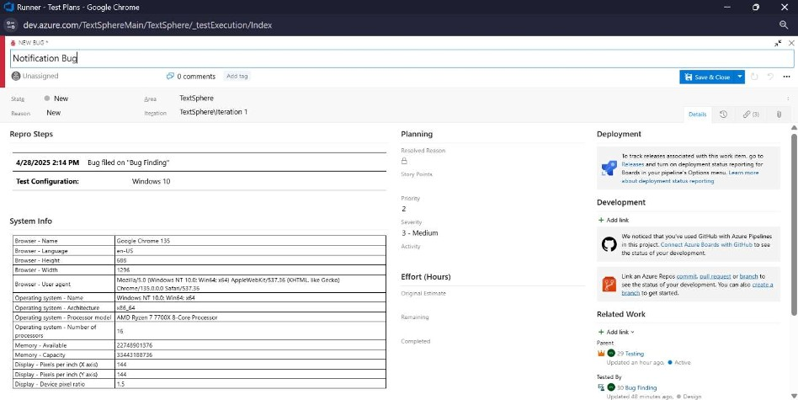

4.

Creating

the

bug

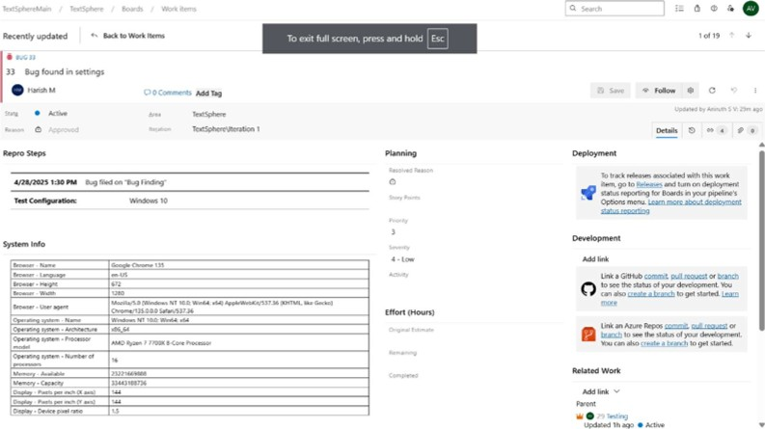

Test case results

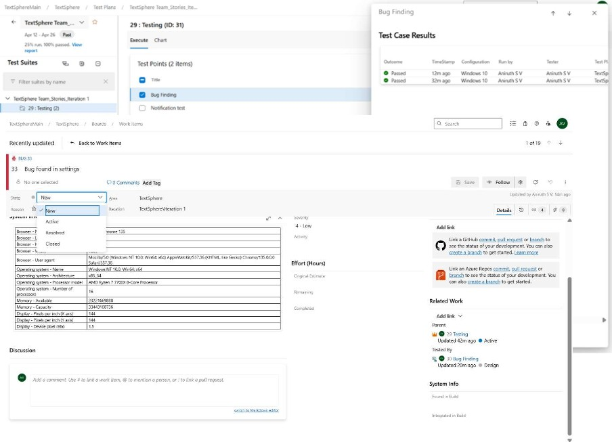

5. Test report summary

 Assigning bug to the developer and changing state

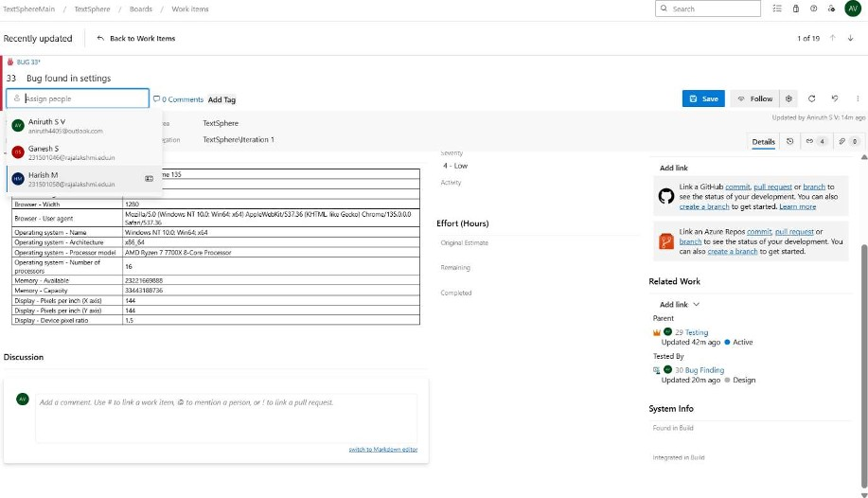

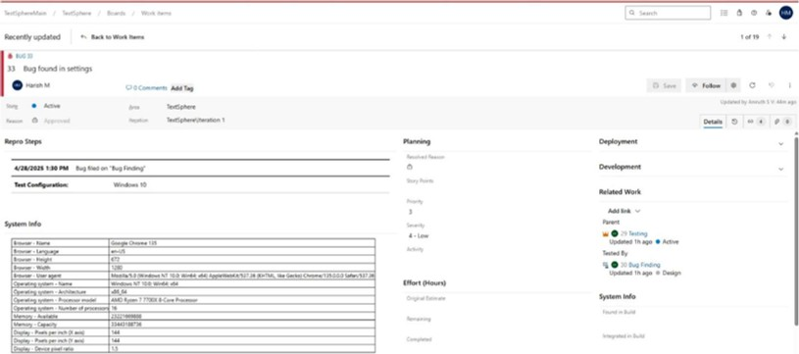

Progress report

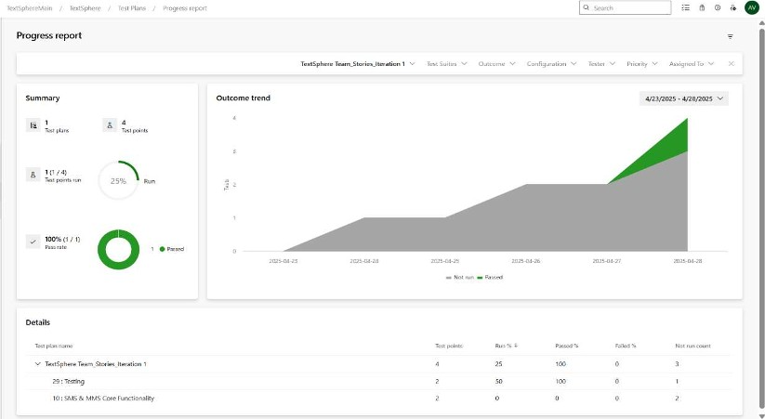

1. Changing the test template

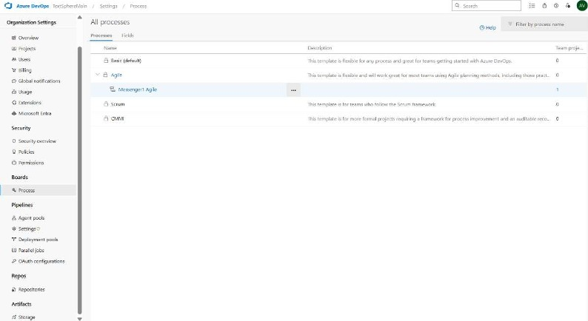

1. View the new test case template

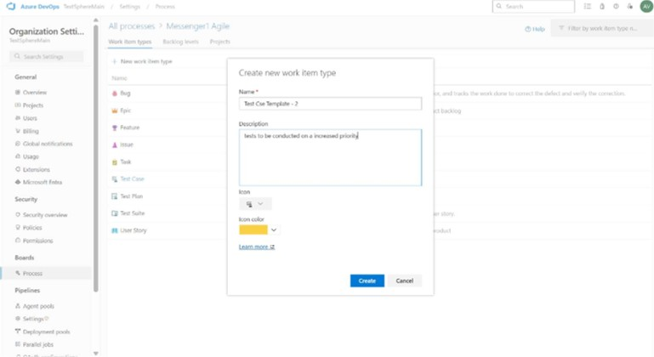

Result:

The test plans and test cases for the user stories is created in Azure DevOps with Happy Path and

Error Path

|  |  |
| --- | --- |
| EXP NO: 9 | LOAD TESTING AND PERFORMANCE TESTING |

Aim:

To create an Azure Load Testing resource and run a load test to evaluate the performance of a target endpoint.

Load Testing

Steps to Create an Azure Load Testing Resource:

Before you run your first test, you need to create the Azure Load Testing resource:

Sign in to Azure Portal

Go to https://portal.azure.com and log in.

1. Create the Resource o Go to Create a resource -+ Search for "Azure Load Testing".
   * Select Azure Load Testing and click Create.
2. Fill in the Configuration Details o Subscription: Choose your Azure subscription.

 Resource Group: Create new or select an existing one. o Name: Provide a unique name (no special characters).

* + Location: Choose the region for hosting the resource.

1. (Optional) Configure tags for categorization and billing.
2. Click Review + Create, then Create.
3. Once deployment is complete, click Go to resource.

Steps to Create and Run a Load Test:

Once your resource is ready:

Go to your Azure Load Testing resource and click Add HTTP requests > Create.

1. Basics Tab

 Test Name: Provide a unique name. o Description: (Optional) Add test purpose. o Run After Creation: Keep checked.

1. Load Settings o Test URL: Enter the target endpoint (e.g., https://yourapi.com/products).
2. Click Review + Create —4 Create to start the test.

Load Testing

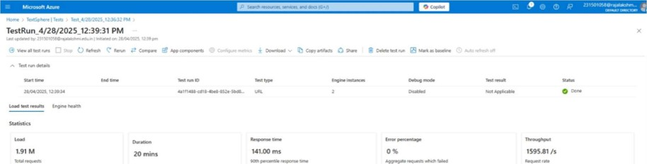

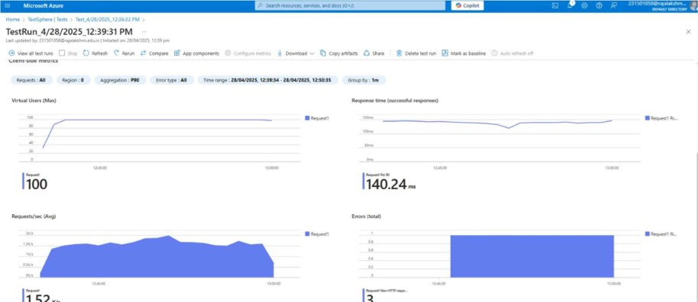

lij52v,

13

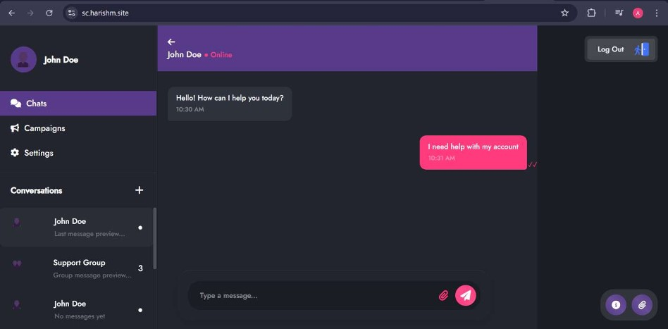

Result:

Successfully created the Azure Load Testing resource and executed a load test to assess the performance of the specified endpoint.

|  |  |
| --- | --- |
| EXP NO: 10 | GITHUB: PROJECT STRUCTURE & NAMING  CONVENTIONS |

Aim:

To provide a clear and organized view of the project's folder structure and file naming conventions, helping contributors and users easily understand, navigate, and extend the SMS/MMS Sending Project

##### GitHub Project Structure

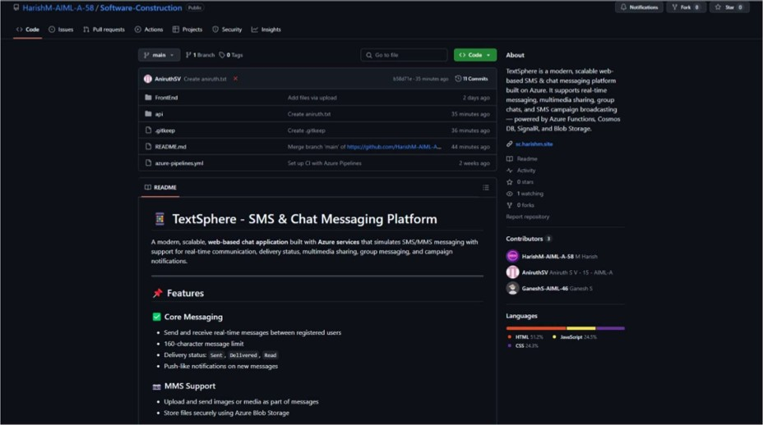

Result:

The GitHub repository clearly displays the organized project structure and consistent naming conventions, making it easy for users and contributors to understand and navigate the codebase.

1. CS23432